Creating a Cardano Wallet

Make sure you write down the 24 words of your wallet recovery phrase on a piece of paper in the exact order shown here (take no shortcuts, those words are crucial!)

Yes, I wrote it down carefully

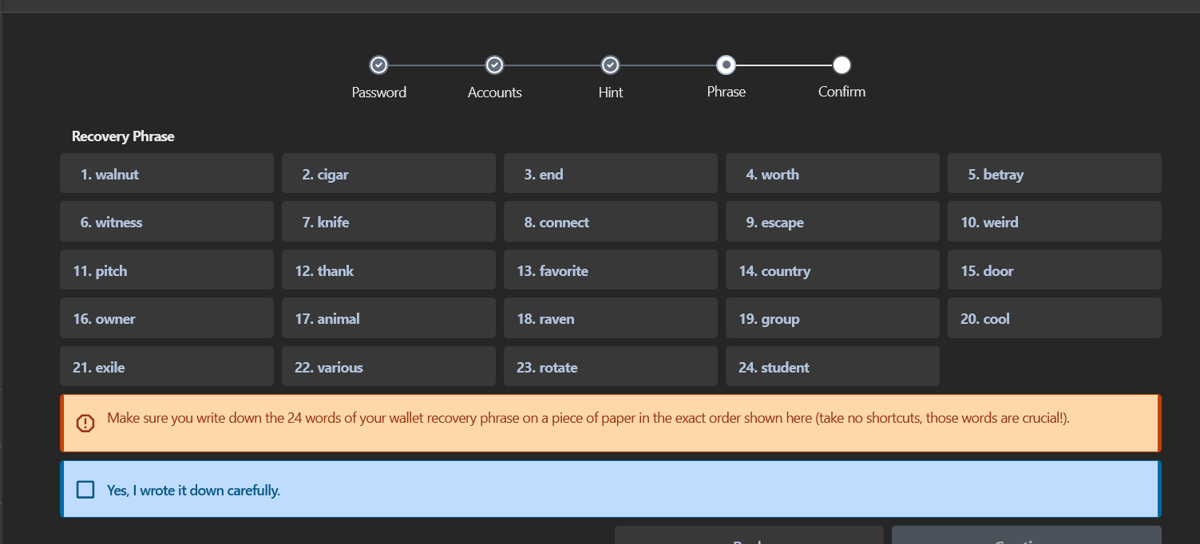

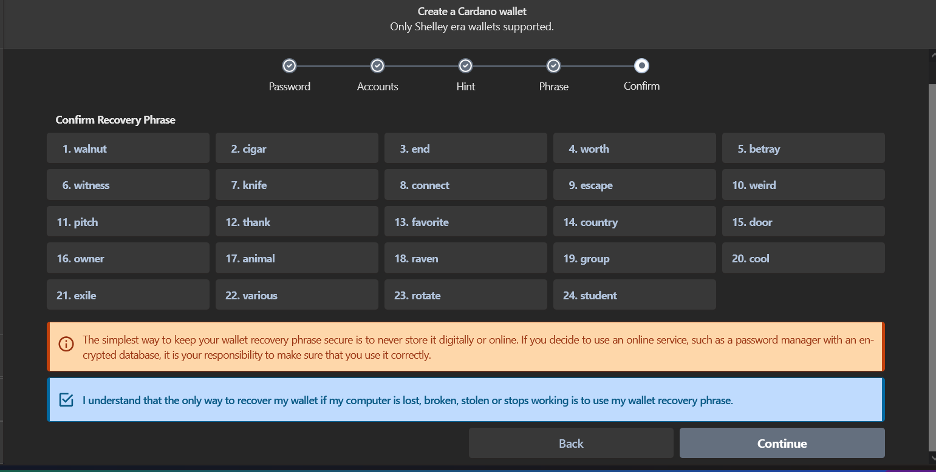

Confirm takes a while like 1-2mins.

